02- A

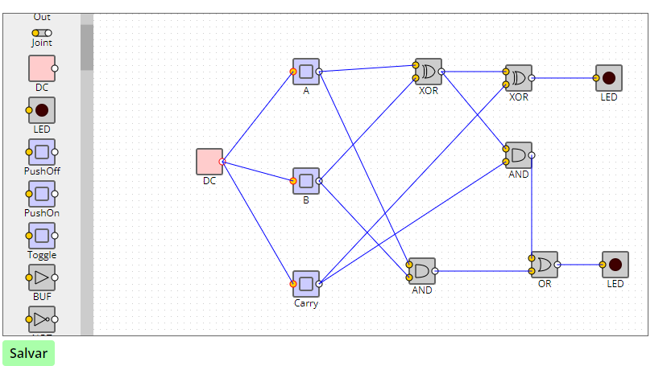

<https://kazuhikoarase.github.io/simcirjs/#-Nv4YTFMSOQeBnPAJOeA>

02- B

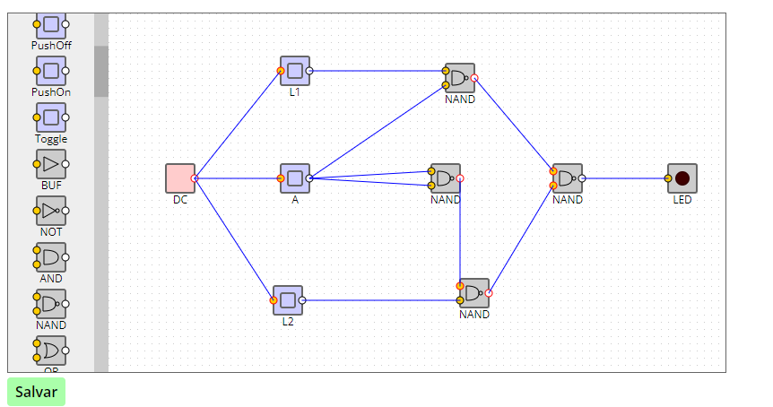

<https://kazuhikoarase.github.io/simcirjs/#-Nv4_ME2sDlQmngbak8D>

02- C

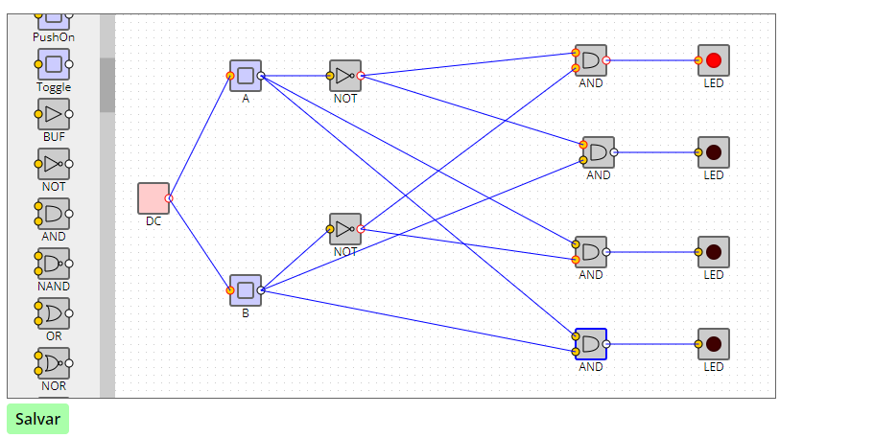

<https://kazuhikoarase.github.io/simcirjs/#-Nv4ahIvMynuS2AfWGAi>